QR Code, Face Recognition, and Google Location as Alternative Solution for Attendances in Private Colouring Studio

Oscar Wongso
S1 Informatics Engineering, Universitas Kristen Maranatha
Jln. Suria Sumantri No.65, Bandung
oscar.wongso@itmaranatha.org

Abstract — RFID and biometric time attendance have been used to taking employee’s attendances in attendances. But they have disadvantage which is cost a lot in terms of prices when need to be used in several places at the same time. An alternative solution was given by using android application which utilizing QR-Code, Face Recognition, and Google Map Location technologies implemented in smartphone to taking employee’s attendances. A test for this system was conduct on one of private coloring studios in Bandung, and from the results shown that using this android application help the employees to take attendances. This paper explains the architecture, design, research findings, and future improvements of attendance system and features.

Keywords— Attendance, Google Location, QR-Code

- Introduction
Private training centre usually have several part time employees which working by giving materials and presentations in client’s places. Employees need to mark their arrival and leaving time manually and getting signature from clients, which will be used as evidences that they already giving training with exact times. These evidences will be collected and recorded into one list of report. To help collect and record list of employee’s attendances, owner of the company reconsider to buy fingerprint attendance tool, and each time employees going to client’s places, they need to bring a fingerprint attendance tool. A problem occurred when the employees need to be working parallels in more places in same period, the company need to supply and collect attendance data from many fingerprint tools, which means more spending costs and works for company. To solve these problems, an alternative solution was given by utilizing QR-Code, Face Recognition, and Google Location technologies in mobile applications on Android smartphone, which already owned by most of the employees.
Several mobile applications already been developed by utilizing QR-Code, Face Recognition, and Google Location technologies in researches. Some of them were used to collect student’s attendance data [1] [2], locate places by using QR-Codes and Location [3] [4], and they showing good results in their researches. From these, we can conclude that QR-Codes, Face Recognition, and Google Location are a good approach to solve the problems in collecting attendances data and replacing fingerprint attendance tool for companies.
For the implementation, this paper proposed different design and architecture of attendance system by using desktop application to generate QR Code and give attendances report, SOAP web service as function to input and output data from smartphone, and mobile application in android smartphone to collect data. For the system process, employees use their phone to check-in after get to client’s places and check-out when they finished teaching, while the web services collect attendances data from smartphone and put them in database server.
To help in achieving the implementation, this mobile application was built and tested in real scenario by using private colouring studio in Bandung as a case study. From the tests, there are also several problems shown related to employee’s cheating. To minimize the cheating, some features are developed like QR Code Error Log and Employee’s Attendances Log that can only be used by owner of the companies. Using this attendance system, it helps company’s owner to reduce spending cost in terms of attendance tools, and reduce time needed to gather and collect employee’s reporting data.

- Related Works
RFID devices have already been used to collect attendance data from arrival to leaving time. The advantages of using this technology are the low cost prices for RFID card if used on a lot of people, but it is different with the reader/writer which have higher prices, and it cost so much if implemented in several locations [5] [2]. The problem also shows on Biometric time attendance like fingerprint and face recognition devices [6]. In other occasion, mobile phone also used to be a backup system to help if there are any case with electricity or system part problems [7]. But these devices are still used in a lot of companies, industries, and schools because they are easy to use, easy to install, easy to integrate with other system or application, and high reliability of data [8].
With technology evolved, a lot of smartphone already implemented features like, NFC which can read RFID tag, Fingerprint, and Face Recognition technologies. Using these features, collecting and gathering attendance data can be replaced by using smartphones [9]. But some of these features are not available in low or medium smartphone specification, so another way to collecting data is by using camera to scanning unique tag like QR Code [10] and GPS for determine location where user take attendance from [11] [3], which available in all smartphones. There also some researches using other method like BLE (Bluetooth Low Energy) Beacon which can automatically capture student’s attendances in classroom [12], and Face Recognition using front camera to collecting attendances data [1] [13]. But most of researches conducted are prefer to use QR Code, and they have showed good results like, easy to implemented, low cost implementation, fast data response, can scanning from different rotating view, can be printed on different things, and no need for complicated hardware and software infrastructures [14] [4] [15].
In this research, the technologies used to collect attendances data are, Face Recognition to help minimize employee’s cheating like using others to help them check-in or check-out, QR Code to help differentiate location pinpoint, and GPS by using Google Location based to set attendance pinpoint. By using these three technologies, an attendance system is developed to help owner of the company to monitor their employee’s attendance using Desktop and mobile application in Android smartphone.

- Research Method
The methodology that used in this research is using ADDIE Models [16] which include Analysis, Design, Development, Implementation, and Evaluation Process shown as below.
- Analysis
In the analysis process, the environment of the project and problems are clarified. Below is the manual process of collecting employee’s attendance shown at Figure 1. In this figure, shown that employees need to make attendance report each time they already finish give training to students in school, and they will be given attendance mark from teacher. The problems in this manual system is there a lot of employees that increasing their leaving time or decreasing arrival time and some employees even asked others to help them fill the attendance.
- Design
In the design process, attendance system is designed by looking at the requirements in the analysis step, which cover the process of gathering employee’s attendance data and collecting them as one attendance report.
In this phase, the architecture of the system also listed in a blueprint, which will be used in development phase. In Figure 2 and Figure 3 listed the attendance system process, web service used, and architecture of attendance system. For the architecture, a desktop application is used to generate QR Codes, and web service used to connect to database server which process all of the data that used in smartphone and desktop application. Figure 4 shown the database diagram that used in this attendance system like user, user’s photo, attendance, and location tables. In location table, there also Latitude and Longitude fields that used for set Google Location, the Code field used to store QR Code unique code.
Figure 1 Employee Manual Attendance

Figure 2 Employee Attendance Data Processing

Figure 3 Attendance System Architecture
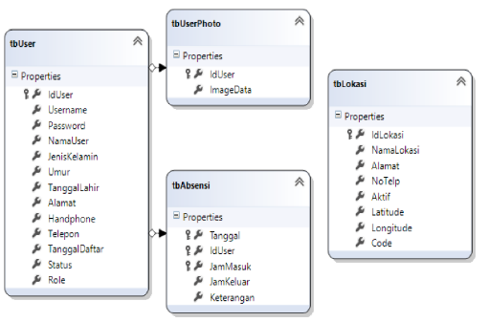
Figure 4 Attendance System Database Diagram
Several features designed in application listed by using UML Diagram consists of Use Case and Class Diagram shown below.
B.1. Use Case Diagram:
There are two roles shown on Figure 5 at Use Case Diagram, which is employee and owner. Features that implemented in system are, login, logout, set location, check-in, check-out, add user’s photo, view employee attendance, and view QR Code Error log.

Figure 5 Use Case Diagram
B.2. Class Diagram:
For the class diagram, it was divided by two types of class, SOAP Service and classes related to business process shown at Figure 7 and Figure 8.

Figure 6 Business Process Classes

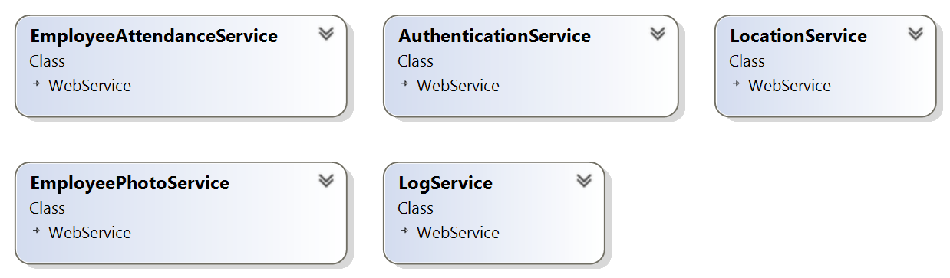
Figure 7 SOAP Service Classes

- Development
The blueprints that created on Design phase are developed in Development phase. The system’s specifications used to develop attendance system are listed on Table 1 below. To help in processing QR Code and Face Recognition there are some open source libraries used, Messaging Toolkit for encode unique code into QR Code, Zxing QR Code Scanner for scanning QR Code, and OpenCV Manager to help in face recognition and detection.

Table 1 Attendance System’s Specifications
Specification | Attendance System
Specification | Desktop Application | Web Service | Mobile Application | Database
Technology | .NET 4.0  Windows Form | SOAP Service ASP.NET | Android  Ice Cream Sandwich | Microsoft  SQL Express 2008
Features | Generate QR Code,  Print QR Code to image file | Location,  Authorization,  QR Code,  Face Recognition,  Attendance Services | Login,  Logout,  Face Data Processing,  QR Code Data Processing,  Location Data Processing,  Attendance Data Processing | Face Data,  QR Code Data,  Location Data,  User Data,  Attendance Data
Libraries | Messaging  Toolkit  QR Encoder | - | Zxing QR Code Scanner,  OpenCV Manager | -

C.1. User Interface:
Below are the user interface designs implemented in desktop application and mobile application. Desktop application are used to generate QR Code and registered the QR Code data to database, and Mobile application to authorize the users and registered employee’s attendances data to web service.

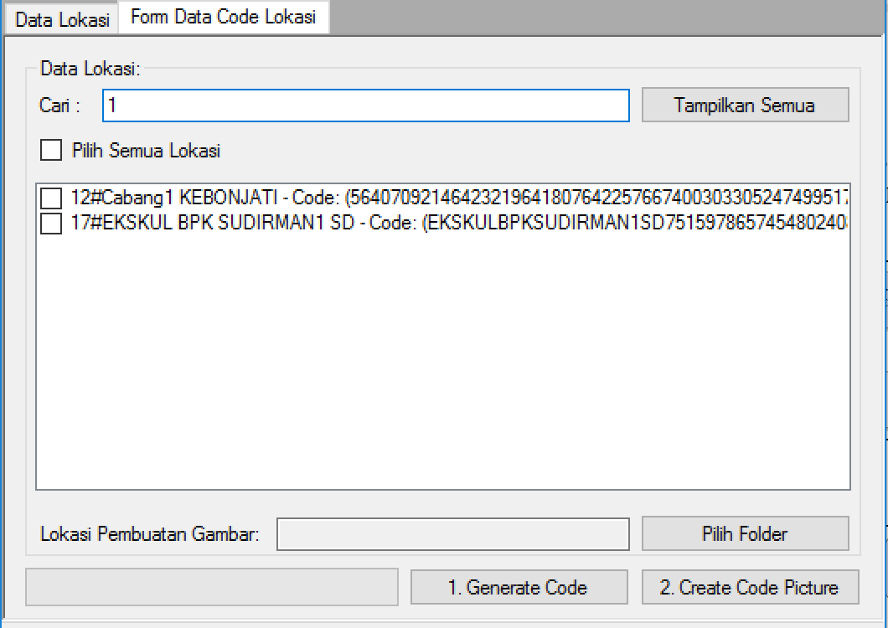
Figure 8 QR Code Generator User Interface
Before employees can check-in and check-out in attendances, they need to login first using username and password given shown at Figure 9. Owner need to set the location first on where the QR Code should be placed on several schools using user interface shown at Figure 8.

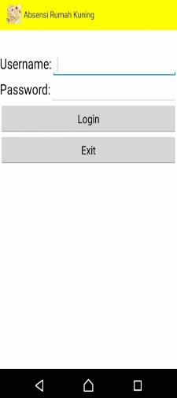
Figure 9 Login Menu

Below are also listed some user interfaces used by employees after they successfully login. First the smartphone will check the location whether the employees are near on the specific locations shown at Figure . Owner can set location by pressing at specific map location showing on Figure . After the location checking shown at Figure , the system will check whether employee has already check-in or not, if the employee hasn’t check-in, the check-in button will show-up and can be chosen, else the one that shown will be check-out button. After the button chosen, face recognition menu will be shown on smartphone, which will detect and recognize employee’s face shown at Figure 13. If the specific face recognized, QR Code scanner will be shown next, which has user interface like Figure . Lastly in the QR Code Scanner menu, employee need to scan specific QR image to send attendance data to web service.
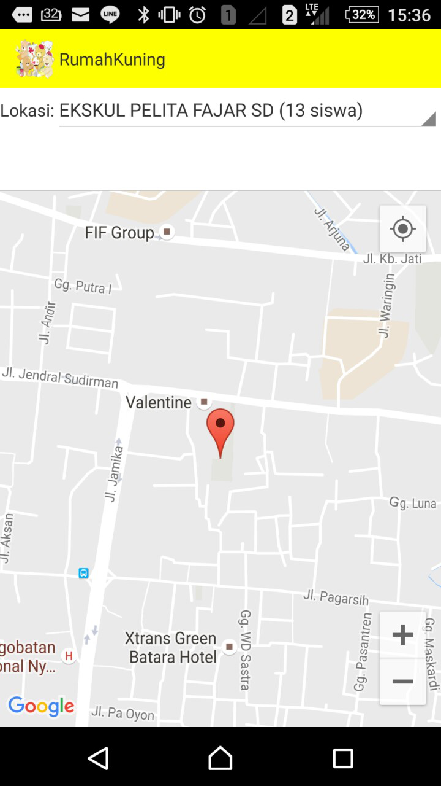
Figure 10 Setting Location

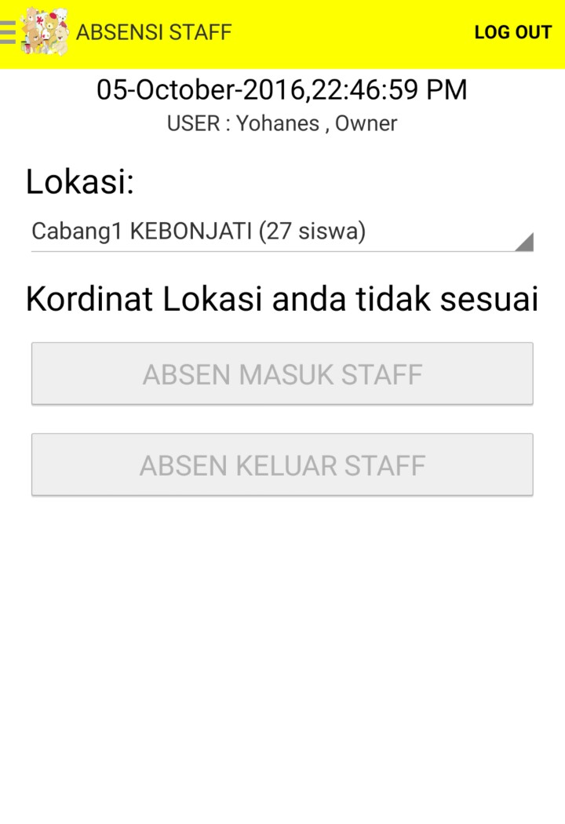
Figure 11 Checking Location

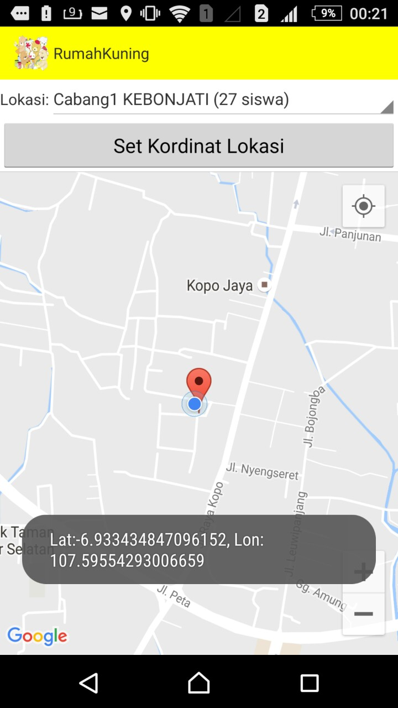
Figure 12 Setting Location

Figure 13 shown on face detection menu, where employee need to scan their faces. If their face is the same with previous save face data, it will then show QR Code Scanning as shown below as Figure .
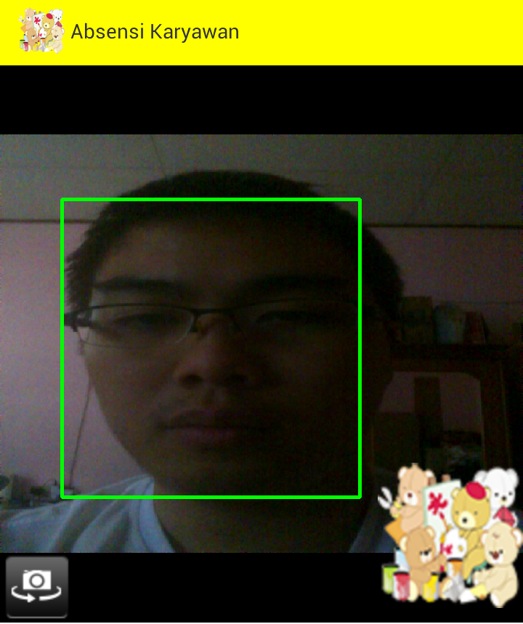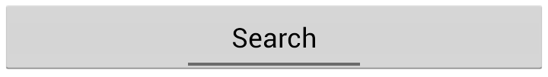
Figure 13 Face Detection Checking

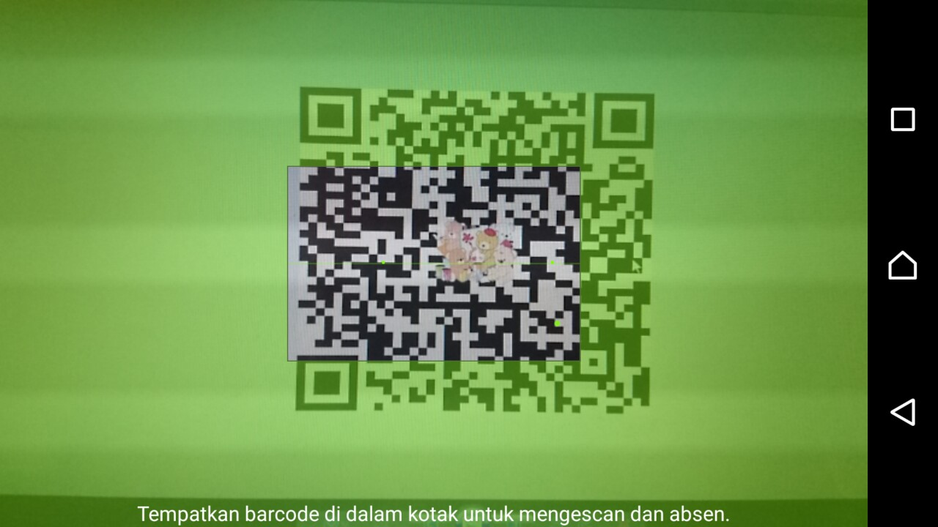
Figure 14 QR Code Scanning

Several pictures related to the design of mobile applications like Main Menu shown at Figure 15, View Report on Mobile shown at Figure 16 and Figure 17.
Figure 15 Main Menu
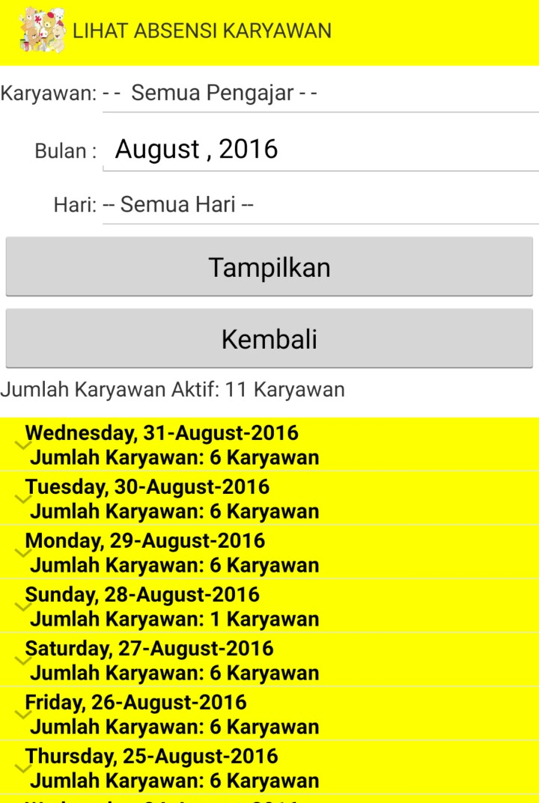
Figure 16 View Employee’s Attendance Report

On Figure 16 and Figure 17, shown employee’s attendance report. In this report, owner or admin can see all of employee’s attendances filtered by name of the employee, months, years, and days. On this report also shown how many employees that are still counted as an active worker. When the report of employees clicked, it will show employee’s data in more detailed version.
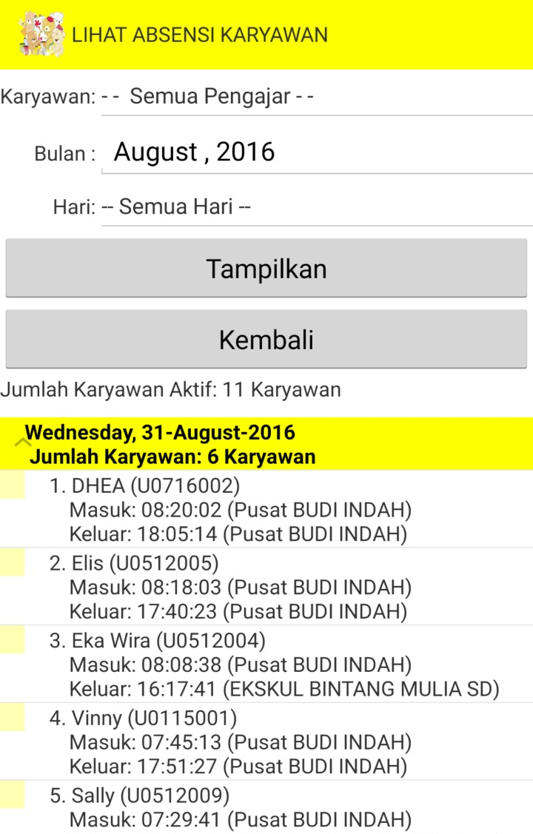
Figure 17 View Employee’s Attendance Report

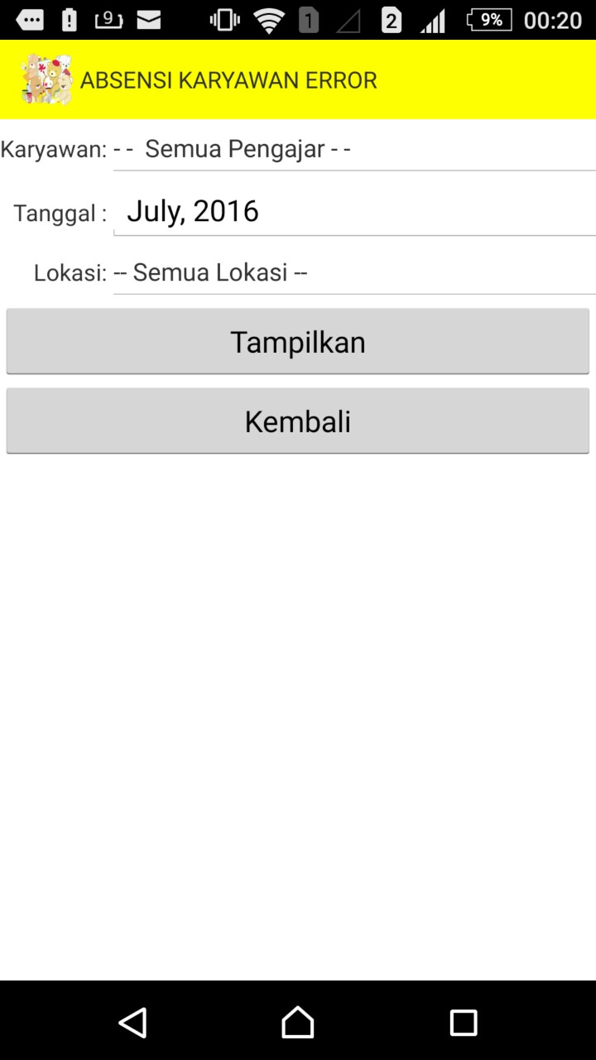
To help in prevent employee’s cheating in using QR Code as security. There also a QR Code Error Log to see whether there are any employees that tried to cheating by using other QR Code or bypassing the GPS shown at and Figure 19.
Figure 18 QR Code Error Log

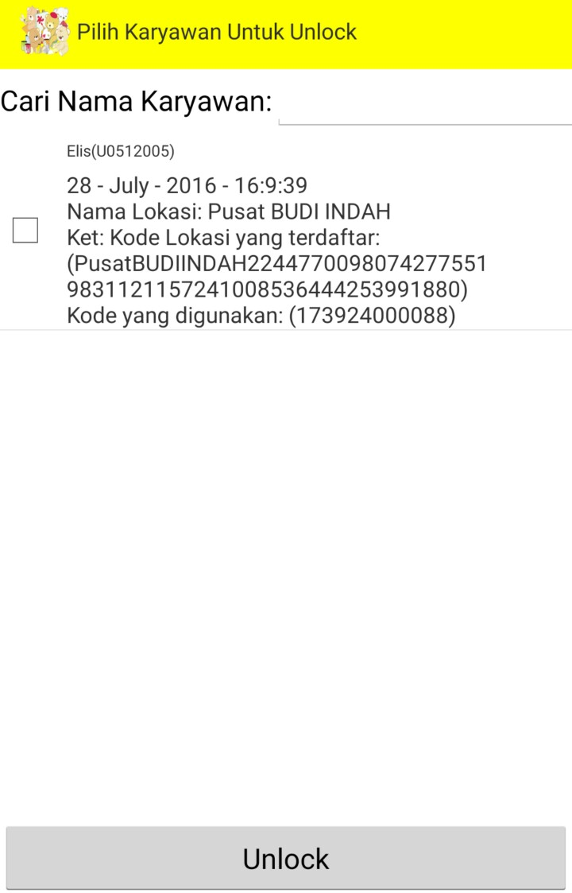
Figure 19 View Employee’s Attendance Report

In Figure 19 shown that there is one employee that tried to use other QR Code to bypass the real QR Code which specified to specific location. In this menu, owner need to give unlock permission, so employee can input her attendance.

C.2. Service Implementation:
Below are listed services implementation, consist of Authentication Service, Employee Photo Service, Location Service, Employee Attendance Service, and Log Service.

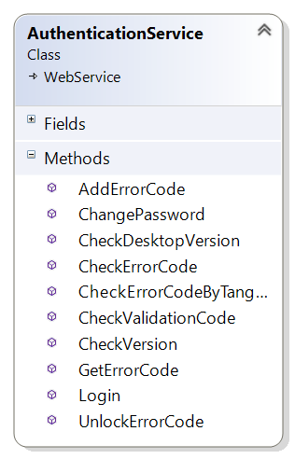
Figure 20 Authentication Service
In Authentication Service, all of processes related to login and error code are listed at Figure 20. While Employee Photo Service used to focus on input employee’s photo, and processed it to string, so it can be stored in database showed at Figure 21.
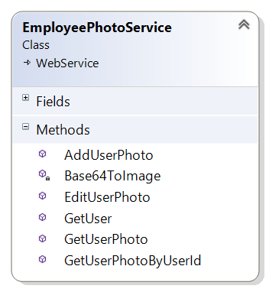
Figure 21 Employee Photo Service
Location Service processes coordinate data, and provides Location data from database Figure 22. Employee Attendance Service are used to input data from smartphone related to employee’s attendances service. This service also has methods for checking whether employee already input their attendances or not showed on Figure 23.
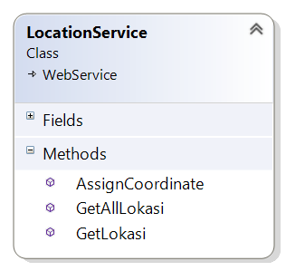
Figure 22 Location Service
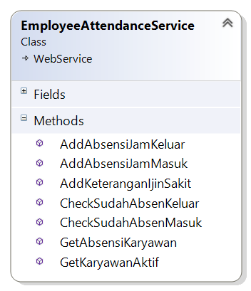
Figure 23 Employee Attendance Service
Log Service used to get employee’s attendances log from database showed on Figure 24.
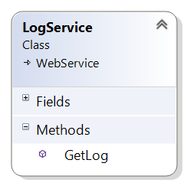
Figure 24 Log Service
- Implementation
Implementation phase contains of the employees and owner training in using the system. A manual book also created to help in using android application, which covers the processes of installation, authorization, generating QR Code, and using the mobile application.
Steps that are covered in this phase are consist of:
- Giving explanation to owner about how to use desktop application to input location data.
- After input location data, the training continues to generate unique codes that will be converted into QR Codes.
- Help owner print the images to printed files.
- Pinpoint all location data using smartphone application.
- Helping employees to register their login data.
- Giving explanation how to download the smartphone application
- Helping employees to login using their username and password.
- Giving explanation about how to do check-in and check-out attendances.
- Giving explanation to owner about how to view employee’s attendances and QR Code Error log.
- Evaluation
To evaluate the attendance system, it was given to 15 (fifteen) employees which formed in android application. The time process of evaluation is conducted in one year. After the test conducted, each of employees was given a questionnaire to help in fixing and improve the attendance system. Some of the questions conducted are shown on Table II.

Table II Attendance System Questionnaire
No. | Questions | Answers
1. | Application is easy to use. | 1(bad) to 5(good)
2. | Application processing is fast. | 1(slow) to 5(fast)
3. | Face Recognition processing is fast. | 1(slow) to 5(fast)
4. | QR Code processing is fast. | 1(slow) to 5(fast)
5. | Location processing is fast. | 1(slow) to 5(fast)
6. | Specify the problems that shown on application. | Essay
7. | Specify the suggestion that need to improve. | Essay

- Results And Discussion
From the developed attendance system, QR Code and Google Location shown good results as alternative solution in collecting and gathering employee’s attendances data. But questionnaire shown that Face Recognition doesn’t shown much results in fields and implementation shown on Figure 25. Without enough lights, sometimes the algorithm failed to detect the faces.

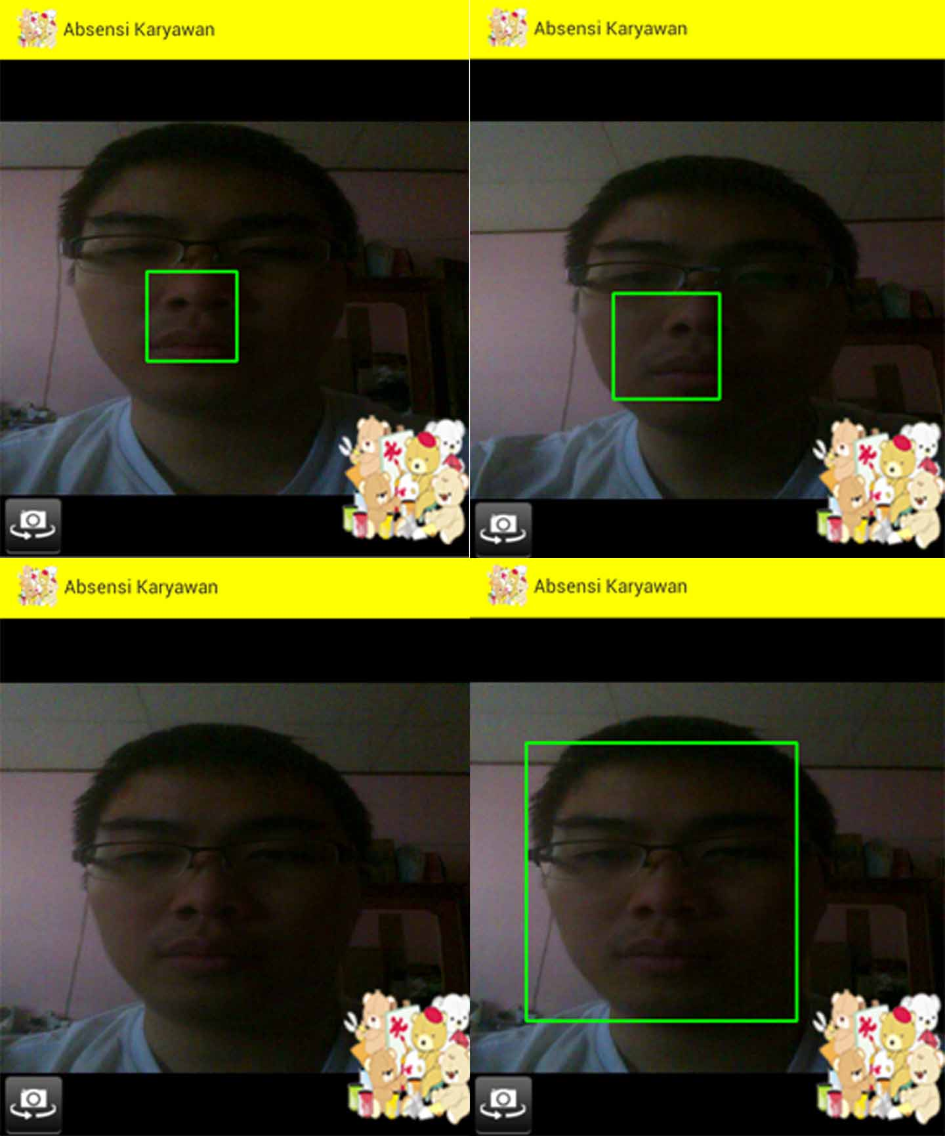
Figure 25 Face Detection
There were also some variables that need to be configure in the application and libraries to get good results, these variables are shown on Table IV.
Table III Questionnaire Results
No. | Questions | Answers
1. | Application is easy to use. | Average
2. | Application processing is fast. | Average
3. | Face Recognition processing is fast. | Slow
4. | QR Code processing is fast. | Average
5. | Location processing is fast. | Slow
6. | Specify the problems that shown on application. | - Slow internet connection.  - Cannot scan QR Code well.  - Cannot assign face detection well.  - Cannot detect face detection well.  - Location not found easily.
7. | Specify the suggestion that need to improve. | - Make the menu more simple

In attendance system variables, unique code length used are 50 alphabets to help in securing code generated, while QR Code scale need to be high about 10 in value, so the images can be printed larger, the QR Code Error correction also need to low about 30%, so it can be scanning faster by the phone. On the other variable, float scale detection on face recognition cannot be set too high because it will affect the recognition, low lights and front camera specification also affect the detection performance. Because of location usually not found easily based questionnaire results, there also had been done some justifications like change the google location precision.
Table IV Attendance System Variables
Variables | Attendance System
Variables | Desktop Application | Mobile Application
QR Code | Unique code length = 50,  QRCode Scale = 10,  QRCode Error Correction = 30% | Scanner Mode = QR_Code_Mode
Face Recognition | - | Float Scale Detection = 1.2 (Low Detection on Face)
Google Location | - | Distance detection = 100m

- Conclusion
The results from implementation process and surveys can be drawn some conclusions about this attendance system which are:
- From survey’s results, the attendance system helps to covers employee’s attendance using QR, and Google Location as cheap alternative solution.
- From the results also shown, that using QR Code and Google Location for taking attendances is faster than face detection, because face detection really depends on smartphone’s phone camera and light.
- To have good results for face detection, front camera should at least have 5 mega pixels and there are good light or flash.
- From attendances system results shown that there at least 5% of employees tried to scan wrong QR Code each day to bypasses the attendance security. To secure this step, a Google Location using GPS is used, so the employees need to scan QR Code on specific location. However, if the employees ever tried to scan other QR Code, or bring specified wrong QR Code to whichever Locations that haven’t been set yet, the system also need to give warning to the owner of the company, so one can know whether his or her employees tried to cheating in taking attendances.

- Future Works
Some future improvements that can be developed and implemented in this attendance system are:
- Improve attendance processing data to check client’s attendances, in this case study, it works for student’s in each school.
- Integration with other operating system like Windows Phone and iOS.
- Improving face recognition algorithms, so it can detect well even in low light environments and poor camera’s specification.

References

[1] | I. Apps, “School Attendance,” 30 04 2016. [Online]. Available: http://www.attendance.mobi/school-attendance.
[2] | A. O. T., A. Olatunbosun, F. O. A. and O. M. and Olaniyi, “RFID-Based Students Attendance Management System,” International Journal of Scientific & Engineering Research, pp. 1-9, 2013.
[3] | S. F. A. Razak, “Interactive android-based indoor parking lot vehicle locator using QR-code,” in 2015 IEEE Student Conference on Research and Development (SCOReD), Kuala Lumpur, 2015.
[4] | F. Hakimpour and A. Z. Zardiny, “Location Based Service in Indoor Environment Using Quick Response Code Technology,” in The 1st ISPRS International Conference on Geospatial Information Research, Tehran, 2014.
[5] | S. Nainan, R. Parekh and T. Shah, “RFID Technology Based Attendance Management System,” IJCSI International Journal of Computer Science Issues, pp. 516-521, 2013.
[6] | M. M. M. Thein and C. M. N. H. M. Tun, “Students’ Attendance Management System Based On RFID And Fingerprint Reader,” NTERNATIONAL JOURNAL OF SCIENTIFIC & TECHNOLOGY RESEARCH, pp. 30-38, 2015.
[7] | J. Sospeter, R. S. Sinde and S. Kaijage, “A Review on Development of RFID and Mobile Application Based Attendance Management System.,” Computer Engineering and Intelligent Systems, pp. 27-32, 2015.
[8] | A. Bluemner, “7 unexpected and awesome uses of RFID tags,” 30 April 2016. [Online]. Available: http://rfidarena.com/2014/3/4/7-unexpected-and-awesome-uses-of-rfid-tags.aspx.
[9] | J. Choi, D. yoon and J.-H. Chang, “A System for Marking the Absence using a Smart-Phone,” Journal of the Korea Academia-Industrial , pp. 4160-4168, 2011.
[10] | F. Masalha and N. Hirzallah, “A Students Attendance System Using QR Code,” (IJACSA) International Journal of Advanced Computer Science and Applications, pp. 75-79, 2014.
[11] | T. Alexandridis, P. Charonyktakis, A. Makrogiannakis, A. Papakonstantinou and M. Papadopouli, “Forthroid on Android: A QR-code based Information Access System for Smart Phones”.
[12] | M.-Y. Bae and D.-J. Cho, “Design and Implementation of Automatic Attendance Check System Using BLE Beacon,” International Journal of Multimedia and Ubiquitous Engineering, pp. 177-186, 2015.
[13] | C. Liu, “The development trend of evaluating face-recognition technology,” in Mechatronics and Control (ICMC), 2014 International Conference on, Jinzhou, 2014.
[14] | D.-J. Cho and M.-Y. Bae, “A Study on Development of OTIP System using QR Code based on Smartphone,” International Journal of Multimedia and Ubiquitous Engineering, pp. 261-270, 2014.
[15] | K. Lee, “Implementation of Smartphone System using QR Code in Mobile,” International Journal of Software Engineering and Its Applications, pp. 137-146, 2013.
[16] | R. M. Branch, “Instructional Design: The ADDIE Approach,” London, Springer, 2010, pp. 23-163.
[17] | E. Prasetyo, Data Mining, Mengolah Data Menjadi Informasi Menggunakan Matlab, Yogyakarta: Penerbit Andi, 2014.
[18] | W. F. Senjaya dan B. Rahardjo, “Implementasi dan Pengukuran Kinerja Operasi Aritmatika Finite Field Berbasis Polinomial Biner,” Jurnal Teknik Informatika dan Sistem Informasi (JuTISI), vol. 1, no. 2, pp. 183 - 193, 2015.
[19] | M. Ayub dan A. I. Widjaja, “Implementasi dan Pengukuran Kinerja Operasi Aritmatika Finite Field Berbasis Polinomial Biner,” dalam Seminar Teknk Informatika dan Sistem Informasi (SeTISI), Bandung, Indonesia, 2013.
[20] | IEEE, “IEEE Website,” [Online]. Available: http://www.ieee.org. [Diakses 25 Januari 2016].
[21] | Cartalyst, “Stripe-laravel Manual,” [Online]. Available: https://cartalyst.com/manual/stripe-laravel/4.0. [Diakses 25 Januari 2016].
[22] | Oracle Inc., “Oracle NoSQL Database Documentation,” [Online]. Available: http://www.oracle.com/technetwork/database/database-technologies/nosqldb/documentation/index.html. [Accessed 25 Januari 2016].
[23] | C. He, Analysis of Security Protocols for Wireless Networks, Stanford University, 2015.

