Performance Analysis the Using of NFS Protocol for ESXi Virtualization Datastore

Billy Susanto Panca
Faculty of Information Technology, Maranatha Christian University
Jl. Prof. Dr. Surya Sumantri. No 65, Bandung
billy.sp@it.maranatha.edu

Abstract — Hypervisor virtualization that used bare metal architecture allows to allocate and provide resources for each created virtual machines. Resources such CPU and memory can be added/upgraded anytime to host hardware (virtualization server) to be able to create more virtual machines. However, upgrading the hard drive size cannot be done anytime if there are already have data or virtual machine that has fully operated on the host hardware, related to the raid system and the establishment hard drive partition.
Upgrading hard drive size on virtualization server can be done by using NFS protocol on NAS server. VSphere ESXi able to use NFS protocol and store the virtual disk that used by virtual machine as guest operating system on network storage besides using local hard drive (host hardware hard drive). When the virtual machine want run the guest operating system, it will request to write/read virtual disk that stored on NAS by using NFS protocol through the network.
In this research, we take measurements on data communication performance due the use of NFS as virtual machine’s datastore besides using local hard drive on server’s device. Measurements were performed by sending various data size from client to server (virtual machine) and measure write/read speed on server’s cache memory and hard drive, and measure RTT (Round-trip Time) delay between client-server. The testing will be conducted on virtual machines that use local drive and NFS as virtual disk datastore.

Keywords— datastore, ESXi, nas (network attached storage), network , nfs (network file system), performance, virtualization, vsphere.
- Introduction
The virtualization concept already widely used for server deployment. One machine can create multiple heterogenous operating system depends on needed. The using of virtualized environment makes deployment more efficient such less power cost then using unvirtualized environment [1]. However, virtualization requires more resources such CPU, memory, and storage space. Each creation of virtual machine will be given CPU, memory, storage, network access, from available resources which provided by the hypervisor. The resources are guaranteed only can be used for concerned virtual machine by the hypervisor [2] [3]. Since CPU, memory, and network adapter are depends on the type of the server, it makes upgrading them are limited. Storage is also limited in the number of hard drive’s slot.
Many storage externalization technology such as NAS (Network Attached Network) and SAN (Storage Attached Network) using NFS protocol already widely used [4]. NFS frequently used to allow user on a client computer to access file through the network like using local storage [5]. The use of external storage is possible to use such as NAS on vSphere datastore to provide more storage space for virtual machines.
NFS implementation as virtual machine datastore can improve flexibility in the process of further development. However, since every data of virtual machine will be stored at different location, it will degrade the output performance such as data communication speed performance. Our research will measure data transfer performance by using NFS as vSphere ESXi datastore such as write/read speed to virtual machine’s cache memory and hard drive, and measure RTT (round-trip time delay) from client side to virtual machine. Testing will be performed on the virtual machines that use datastore on direct attached hard drive and NFS protocol.
- Related Work
Many studies related to the field of virtualization performance and efficiency have been conducted [1] [6]. Maria and Hammad made a research by deployment NAS on ESXi virtual machine uses virtual switch on it. Their research focus on the procedures of NAS implementation on virtual enviroment. They create a virtual machine as NAS and configure NFS protocol for the procedures for accessing the NAS [4]. In our research, we are not create NAS on ESXi but use NAS as ESXi virtual machine datastore by using NFS for write/read communication protocol.
Debabrata and Rajesh provide a model on their research to make an encrypted virtual machine storage on the scope of the private cloud. They realize the importance of using virtual machine to reduce cost during maintenance process and expanding the infrastructure [7]. Our research focused on storage addition efficiency, different from their research that provide storage security model.

Hasan, Lue, and Martin perform benchmarking on the 3 types of virtual machine (Hyper-V, VMware ESXi, and Xen Hypervisor). They did a benchmark on the virtualization approach, architecture, hardware, and software on each virtual machines. They was measuring virtual machines performance based on thread clock tick and memory load. In our research, benchmarking on virtual machine focused on measuring write/read speed on cache memory and hard drive before and after using NFS as virtual machine datastore on ESXi [8].
Vaughn, Michael, Larry, and Peter recommended many methods on their report for improving vSphere storage including using NFS as datastore. However, they aren’t test the impact by using NSF through the value of data communication performance [5].
- Literatur Review
- Virtualization
Since 1960, virtualization has been used for dividing the system resources provided by mainframes computer between different applications [9] [10]. Virtualization is considered to be act of abstracting the physical boundaries of a technology [4]. Virtualization has a major impact on the data center by decreasing a number of physical servers need to run on back office and greatly increasing the manageability and flexibility of that infrastructure. Since there are occurence of physical abstraction such improving security, flexibility and performance, makes one virtual machine separate from one other [7]. While one of them fails, it will completely isolated from all other on a physical machine, including other virtual machines. This is make the problem will be contained and increase the security and manageability [11]. There are several approach of virtualization based on how the virtual machines are controlled [7].
- Operating System-Based Virtualization
In Figure 1 shows the illustrated architecture of operating system-based virtualization. Virtualization is provided by host operating system. It support feature to isolated virtualized guest OS’s on a single physical host hardware even using the same operating system kernel and characteristics. The virtual machines are controlled by the host operating system.
The using of operating system-based virtualization have several weaknesses such performance degradation. Since guest operating system need to performs I/O operation, it need to be interpreted by the host operating system before accesing the hardware which can access the kernel. Extra CPU is needed and lead to performance degradation. Operating system-based virtualization is not flexible as other virtualization approaches since it can’t host a quest OS different with the host one, or a different guest kernel [12].

Fig 1. Architecture of operating system-based virtualization
- Application-Based Virtualization
Architecture of application-based virtualization is shown in Figure 2. The computer programs are encapsulated in a software underlying operating system on which it is executed. Fully application virtualization requires a virtualization layer. Application virtualization layer replace part of the runtime environment normally provided by the operating system. The layer intercepts all disk operations of virtualized applications and tranparently redirects them to a virtualized location [13].

Fig 2. Architecture of application-based virtualization
Application virtualization helps solve the problem of application incompability in an operating system and others by adding a layer of isolation between operating system and the application. This virtualization approach gives administrators a way to create virtualized applications that help minimized risk, save time, increase user satisfaction, and reduce cost for support and regretion testing [14].
There are several limitation of application virtualization [12]:
- Not all software can be virtualized.
- Only file and registry-level compability issues between legacy applications and newer operating system can be addressed by application virtualization.
- Licensing application virtualization must be correctly lisenced between virtualized software and virtualized applications.
- Hypervisor-Based Virtualization
One of many hardware virtualization such hypervisor allow multiple operating systems, termed guest, to run concurently on a host computer. The hypervisor present to the guest operating system a virtual operating platform and monitors the execution of the guest operating systems [7]. The guest software is not limited to user applications, many host allow the execution of complete operating systems. The guest software executes as if it were running directly on the physical hardware [12].
Fig 3. Architecture of bare metal hypervisor-based virtualization
Hypervisor or Virtual Machine Monitor (VMM) is installed on server hardware whose only task to run guest operating systems. The virtualization layer directly control the hardware and manages guest operating systems. Since bare metal model (Figure 3) directly implements the virtualization in the hardware level, made the system overhead transfering I/O operation from guest operating system to the hardward is less than hosted model (Figure 4).
Fig 4. Architecture of hosted hypervisor-based virtualization
The bare metal hypervisors are installed directly on host hardware, just like any other operating system [15]. The size of management software is very small, it makes the resource used by the virtualization layer can be ignored. Since the virtual machines are not built within a host operating system, it is more flexible and reliable for various applications. The hypervisor is available at the boot time of machine in order to control the sharing of system resources across multiple virtual machines [7].
- Advantage of Virtualization
- Cost
Hardware is the highest cost when we build a system. While we can reduce the amount of hardware, that means reduce our cost. It is possible to achieve reductions by consolidation smaller servers into more powerful servers. Cost reduction obtained from hardware cost reductions, operation cost reductions, floor space, and software lisence. The use virtualization can reduce overall cost from 29 to 51%. [1] [7] [16]
- Reliability
A software or operating system failure in a virtual machine does not affect other virtual machines [7].
- Security
The code for hypervisor and boot operating system kept as small as possible, creates a smaller attack surface. Virtual machines run at lower level of permissions than hypervisor, it mades inhibits virtual machines attacks [17].
- Load Balancing
The software state of entire virtual machines is completely encapsulated by the virtual machine management (VMM), it is made relative easy to migrate virtual machine to ether platform in order to improve performance through better load balancing [18]. Since the hypervisor can provide hardware driver from its vendor, the using of multiple network interface will automatically trigger load balancing without any configuration by ESXi it self.
- vSphere ESXi
VMWare ESXi is the next-generation hypervisor, providing a new foundation for virtual infrastrcuture. This innovative architecture operates independently from any general purpose operating system, offering improved security, increased realibility, and simplyfied management [19].
Server virtualization using VMWare’s ESXi is the most dominant and stable virtualization technology. VMWare alone holds 50% of the market share in virtualization, whereas other vendors combine the remaining 50%. A research survey done by F5 networks in the time from September to Desember 2008 reported that VMWare ESXi is the most widely deployed server virtualization product [20].
Besides being the most dominant vendor in the virtualization market, VMWare’s ESXi have a features that make it reliable and favourite choice for IT profesionals [15]:
- Small foot print
ESXi just need 70MB of disk space for instalation. Compared with other bare metal model such Hyper-V with minimum 2GB of disk space and 1.8GB with XenServer v5.6 [8].
- Hardened Drivers
Hardware drivers for virtual machine already optimized by hardware vendors.

- Advance memory management
Feature to reclaim unused memory, duplicate memory pages, and compress memory pages.
- Advance storage management
Feature to provides independent storage management. The alocation of storage can be done without interrupting the other virtual machines or host machine.
- Host resource management
Feature for network traffic shaping, resource sharing for each virtual machines, and allows the setting of quality of service priorities for storage and network I/O.
- Flexible resource alocation
The resource alocation can be done on the fly, such as add virtual CPU, memory, and virtual disk (hard disk space)
ESXi install and runs without the Linux-based Service Console like VMWare ESX. This makes ESXi an ultra light footprint of approximately 70MB. ESXi provide all the same virtualization feature that VMWare ESX provided in earlier versions. The reason that ESXi is able to support the same extensive set of virtualization as VMWare ESX without the Service Console is that the core of virtualization funcionality was not found in the Service Console [8]. VMKernel manages the virtual machines access to the underlying physical hardware by providing CPU scheduling, memory management, and virtual switch data processing [21]. Figure 5 shows the architecture of next generation VMWare virtualization foundation ESXi after ESX.
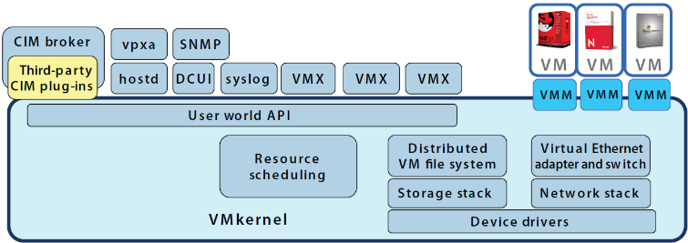
Fig 5. Architecture of VMWare ESXi [16]
- NAS
Network attached storage (NAS) is a term used to refer to storage elements or devices that connect to a network and provide file access services to computer systems. NAS devices attach direcly to networks, such as LAN (local area network), by using TCP/IP protocol and serve files to any client connected to the network. A client computer access NAS devices uses a file system device driver to access the stored data. The file system device driver typically uses a file access protocol such as Common Internet File System (CIFS) or Network File System (NFS). NAS devices interpret these command and perform the internal file and device I/O operation necessary to execute them [22][23].
- NFS
The Network File System (NFS) is designed to be portable accross different machines, operating systems, network architectures and transport protocol to provides remote access to shared files across networks. This portability is achieved through the use or Remote Procedure Call (RPC) primitives built on top of eXternal Data Representation (XDR) [24].
Since the NFS protocol was intented to be a stateless connection, that is made the server should not need to maintain any protocol state information about any of it’s clients in order to function correctly. Stateless servers have a distinct advantage over stateful servers in the event of failure. A client just need to retry a request until the server responds, it does not even need to know that the server has crashed, or the network connection went down. The client of a stateful server needs to either detect a server failure and rebuild the server’s state when it comes back up, or cause operations to fail [24].
All of the procedures in the NFS protocol assumend to be synchronous. When a procedure returns to the client, the client can assume that the operation has completed and any data associated with the request is now on stable storage.
- Experimental Setup
  - Hardware Configuration
The hardware platform used for conduction this research has the following spesification.
- ESXi (Virtualization Server): HP ProLiant DL380 Gen9, Intel® Xeon® CPU E5-2650v3 (20 CPUs, 40 Logical Processor) @ 2.30GHz with 25MB SmartCache, 64GB memory, 4TB hard drive, 6 ethernet port with spec: 4 Broadcom NetXtreme Gigabit Ethernet Port and 2 Broadcom QLogic 57810 10 Gigabit Ethernet Port.
- NAS Server: HP StoreEasy 1550, Intel® Xeon® CPU E5-2603v3 (6 CPUs) @ 1.6GHz, 8GB Memory, 16TB hard drive, 2 Gigabit Ethernet Broadcom BCM5715 NetXTreme.
  - Software Configuration
Hypervisor provided by using lisenced VMware vSphere 6.0 (unlimited cores per CPU). These version where the last shipping releases at the time of doing this research (started in January 2017).
  - Guest Operating System
Windows Server 2012 (64bit) is the guest operating system used on our research. There are two Windows Server 2012, first is stored at virtualization server datastore directly by using local hard drive in it, the second is stored at NAS server by configuring NFS protocol between virtualization server and NAS server for write/read communication protocol.
Windows Storage Server 2012 (64bit) R2 installed at NAS server which provide storage for any client by using NFS protocol.
Windows 10 pro (64bit) installed at Client PC and used for communication testing to both Windows Server 2012.
  - Virtual Machine Configuration
Since this research using ESXi as hypervisor, the created virtual machine will be fully-virtualized instead of paravirtualized. Each virtual machine is configured to have one virtual CPU, 4GB of memory, 40GB hard drive for I/O file testing, and 1 Gigabit ethernet port.
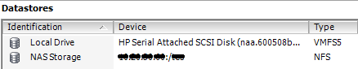
Fig 6. ESXi datastore (VMFSS and NFS)
Figure 6 shows the ESXi have 2 types of datastore. First virtual machine will be installed at “Local Drive”, and the other one will be installed at “NAS Storage”. The communication between ESXi and NAS server is using NFS protocol that allowed ESXi to access shared directory of NAS storage and store virtualization image (.vmdk, .vmx, .nvram, etc) on it.
  - Network Topology
The hypervisor installed at server device and stored at DMZ area and NAS devices as ESXi datastore stored at local area network. Figure 7 shows the connection between ESXi, NAS devices, and PC Client.
Fig 7. Network Topology
Even the both Windows Server 2012 are running at virtual enviroment under ESXi hypervisor, one of it (Windows Server 2012 [2]) is stored at NAS server besides on virtualization server’s local drive. Every times Windows Server 2012 [2] runs, the virtualization server will be ask the files needed (virtual disk) to NAS server by using NFS protocol. Figure 8 shows the NFS protocol communication between virtualization server to NAS server, captured by using Wireshark software.
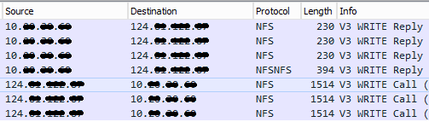
Fig 8. Communication between virtualization server and NAS server
- Testing Procedures and Results
Windows Server 2012 is selected as guest operating system since we used a software that used TCP/IP protocol for transmitting and receiving data between client-server and also measuring write/read data communication speed.
  - Testing Metrics
There are two mechanism of data communication on this test. Write and read data are performed on server’s cache memory and hard drive. Measurements are performed at write/read speed and RTT (Round-trip Time) between client-server.
  - Measuring Process
The measurement on each testing metrics are performed on both virtual machines to obtain the performance difference between using local hard drive and NFS protocol as virtual machines datastore. The measurement will be conducted 1000 times for each scenarios. We conducts test by using four data sizes (100KB, 1M, 10M, 100M) send over network between client-server. For each test, we generate 100 data packets on every data size and do 10 times testing. Therefore, we test client-server communication performance 1000 times in total for each data size.
  - Testing Scenarios
- Write/Read from Client to Server’s Cache Memory
The first testing scenario is sending data from client (PC Client) to server (Windows Server 2012 [1] & [2]) over the network by using TCP/IP protocol. Figure 9 to 16 shows the performance different on write time (ms) to server’s cache memory on 100KB data size on virtual machine which use local hard drive (VMFSS) and NFS protocol as virtual machine datastore to storing virtual disk (.vmdk).
The Figure 9 shows the write process to server’s cache memory using local hard drive is more unstable compared with using NFS protocol.
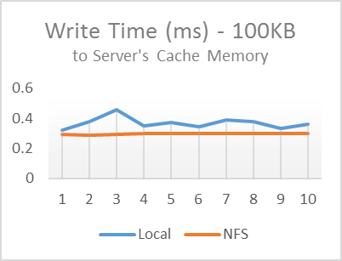
Fig 9. Write Time to Cache Memory – 100KB data size
The average of write time (ms) needed from client to server with 100KB data size is shown in Table I. Every rows shows the average of 100 times testing. Average of 1,000 times write testing with 100KB data size to server’s cache memory shows that using NFS protocol as virtual machine datastore is 24.38% faster than using local drive at host hardware.
Table I
Write Time to Server’s Cache Memory - 100KB data size
No. | Local Drive | NFS
1 | 0.3227733 | 0.293290
2 | 0.3760763 | 0.2896637
3 | 0.4554326 | 0.2945069
4 | 0.3478442 | 0.2956532
5 | 0.3703460 | 0.2957401
6 | 0.3447231 | 0.2963665
7 | 0.3861392 | 0.2986223
8 | 0.3761321 | 0.2956834
9 | 0.3331197 | 0.2974705
10 | 0.3626582 | 0.2978439
Avg | 0.36752447 | 0.29548405
Figure 10 shows the result of read time (ms) from client to server’s cache memory on 100KB data size. The graph shows that read time by using NFS protocol more stable compared by using local hard drive on host hardware.
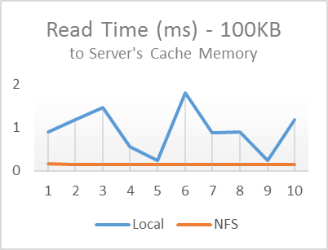
Fig 10. Read Time to Cache Memory – 100KB data size
The average of read time (ms) needed from client to server’s cache memory with 100KB data size is shown in Table II. Average of 1000 times read testing with 100KB data size to server’s cache memory shows that using NFS as virtual machine datastore is 509.67% faster than using local drive at host hardware.
Table II
Read Time to Server’s Cache Memory - 100KB data size
No. | Local Drive | NFS
1 | 0.8973481 | 0.1562289
2 | 1.1820205 | 0.1465906
3 | 1.4616412 | 0.1541129
4 | 0.5558776 | 0.1507121
5 | 0.2318107 | 0.1543894
6 | 1.8124936 | 0.1529284
7 | 0.8802639 | 0.1535888
8 | 0.9002681 | 0.1537114
9 | 0.2330693 | 0.1541873
10 | 1.1792473 | 0.1545411
Avg | 0.93340403 | 0.15309909
Figure 11 shows the value of write time (ms) from client to server’s cache memory on 1MB data size. The graph shows the using of local hard drive are more stable compared with NFS protocol on 1MB than 100KB data size.
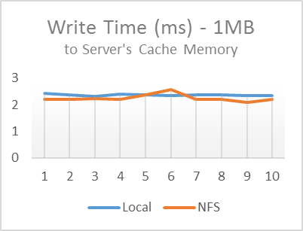
Fig 11. Write Time to Cache Memory – 1MB data size
The average of write time (ms) needed from client to server with 1MB data size is shown in Table III.
Table III
Write Time to Server’s Cache Memory – 1MB data size
No. | Local Drive | NFS
1 | 2.4297315 | 2.2070025
2 | 2.3809750 | 2.2113293
3 | 2.3138561 | 2.2205531
4 | 2.3894056 | 2.2096884
5 | 2.3703614 | 2.3598893
6 | 2.3432618 | 2.5560472
7 | 2.3619025 | 2.1904816
8 | 2.3555105 | 2.1920535
9 | 2.3333875 | 2.0934884
10 | 2.3435219 | 2.1927912
Avg | 2.36219138 | 2.24333245
Average of 1000 times write testing with 1MB data size to server’s cache memory shows that using NFS as virtual machines datastore is 5.29% faster than using local drive at host hardware.
Figure 12 shows the value of read time (ms) from client to server’s cache memory on 1MB data size. The graph shows the read process on 1MB data size by using NFS protocol are more stable and faster than using local drive as virtual machine datastore.
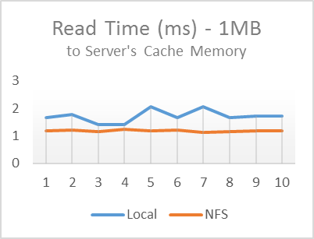
Fig 12. Read Time to Cache Memory – 1MB data size
Table IV shows the average of 1000 times read testing on 1MB data size to server’s cache memory. The using of NFS is 45.01% faster than using local drive as virtual machine datastore.
Table IV
Read Time to Server’s Cache Memory – 1MB data size
No. | Local Drive | NFS
1 | 1.6581289 | 1.1766468
2 | 1.7769015 | 1.2073970
3 | 1.3960516 | 1.1613709
4 | 1.4138687 | 1.2313505
5 | 2.0455276 | 1.1735411
6 | 1.6627443 | 1.1972251
7 | 2.0456758 | 1.1247076
8 | 1.6585109 | 1.1625198
9 | 1.7281476 | 1.1858430
10 | 1.7276530 | 1.1800396
Avg | 1.71132099 | 1.18006414
Figure 13 shows the value of write time (ms) from client to server on 10MB data size. The graph shows the write testing with 10MB data size to server’s cache memory on local drive and NFS are both unstable value compared with previous test.
The Table V shows the average of 1000 times write testing on both servers. The using of local drive is 2.12% faster than using NFS as virtual machine datastore. Compared with previous testing on smaller datasize, write data to server’s cache memory that using local drive as virtual machine datastore on 10MB data size show faster results than using NFS.
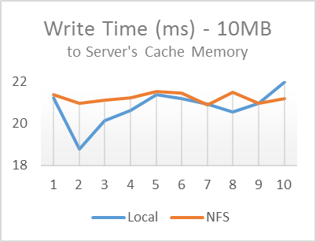
Fig 13. Write Time to Cache Memory – 10MB data size
Table V
Write Time to Server’s Cache Memory – 10MB data size
No. | Local Drive | NFS
1 | 21.2407821 | 21.4034873
2 | 18.7942882 | 20.9534845
3 | 20.1486679 | 21.1149016
4 | 20.6350253 | 21.2316414
5 | 21.3881703 | 21.5485224
6 | 21.1889365 | 21.4456097
7 | 20.9265949 | 20.8925960
8 | 20.5718300 | 21.5166040
9 | 20.9605279 | 20.9692456
10 | 21.9976195 | 21.1947304
Avg | 20.78524426 | 21.22708229
Figure 14 shows the value of read time (ms) from client to server 10MB data size. The graph shows the using local drive are more unstable than NFS as datastore.
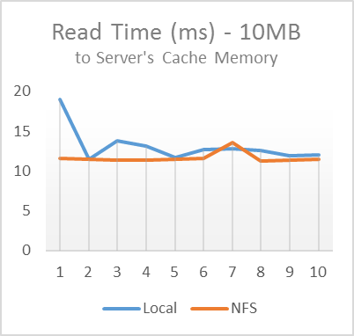
Fig 14. Read Time to Cache Memory – 10MB data size
The Table IV shows the result of 1000 times testing read data from client to server’s cache memory on 10MB data size by using of NFS as virtual machine datastore is 12.35% faster than using local drive.

Table VI
Read Time to Server’s Cache Memory – 10MB data size
No. | Local Drive | NFS
1 | 18.9812338 | 11.5216015
2 | 11.4377432 | 11.4557662
3 | 13.7364794 | 11.3425241
4 | 13.1597428 | 11.3561308
5 | 11.6862156 | 11.4530614
6 | 12.6336952 | 11.6170974
7 | 12.7788510 | 13.5841254
8 | 12.5122481 | 11.2879391
9 | 11.9090408 | 11.3533452
10 | 12.0038139 | 11.4834139
Avg | 13.08390638 | 11.6455005
Figure 15 shows the value of write time (ms) from client to server’s cache memory on 100MB data size. The graph shows that the using of local drive and NFS are both unstable than smaller data size on previous test.
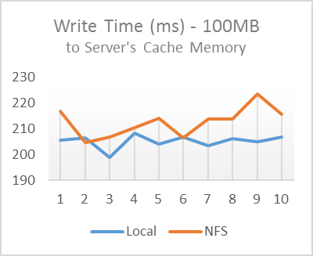
Fig 15. Write Time to Cache Memory – 100MB data size
The Table VII shows the average of 1000 times write testing to server’s cache memory on 100MB data size by using local drive as virtual machine datastore is 3.51% faster than NFS.
Table VII
Write Time to Server’s Cache Memory – 100MB data size
No. | Local Drive | NFS
1 | 205.6173631 | 216.7695078
2 | 206.3029872 | 204.7207051
3 | 198.8206734 | 206.6124627
4 | 208.3145364 | 210.5396421
5 | 204.1249096 | 213.9944990
6 | 206.6413029 | 206.4118865
7 | 203.3173913 | 213.6243310
8 | 206.1648641 | 213.6666022
9 | 204.7953219 | 223.4595259
10 | 206.6063254 | 215.6265829
Avg | 205.0705675 | 212.5425745

Figure 16 shows the values of read time (ms) from client to server’s cache memory on 100MB data size. The graph clearly shows that the using local drive is need less time than NFS on read 100MB data size.
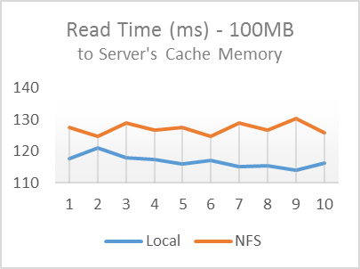
Fig 16. Read Time to Cache Memory – 100MB data size
The Table VIII show the average of 1000 times read testing on 100MB data size to server’s cache memory. The test results show that the using of local drive as virtual machine datastore is 8.90% faster than using NFS on 100MB read test scenario.
Table VIII
Read Time to Server’s Cache Memory – 100MB data size
No. | Local Drive | NFS
1 | 117.6023214 | 127.4876240
2 | 120.9903297 | 124.5415373
3 | 117.8610673 | 128.9027952
4 | 117.2513944 | 126.6516907
5 | 116.0152739 | 127.4876240
6 | 116.9644377 | 124.5415373
7 | 114.9893922 | 128.9027952
8 | 115.4930069 | 126.6516907
9 | 114.0547803 | 130.3600002
10 | 116.2309486 | 125.9291211
Avg | 116.7452952 | 127.1456416
- Write/Read from Client to Server’s Hard Drive
The second testing scenario is sending data from client to server’s hard drive. Figure 17 to 24 shows the performance different on write/read time (ms) from client to server which using local datastore (VMFSS) and NFS protocol as virtual machine datastore.
The Figure 17 shows the results of 1000 times write testing on 100KB data size to server’s hard drive. Same as previous scenario, for every 100 times testing will be conducted average calculation. The graph clearly shows that the using local drive is faster than NFS as virtual machine datastore on write 100KB data size to server’s hard drive.
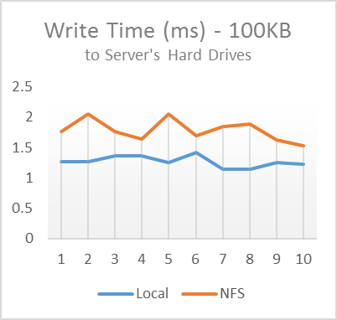
Fig 17. Write Time to Server’s Hard Drive– 100KB data size
The Table IX shows the average of 1000 times write testing results on server’s hard drive on 100KB data size. The results show that the write time on virtual machine that used local drive as virtual machine datastore is 40.58% faster than using NFS.
Table IX
Write Time to Server’s Hard Drive – 100KB data size
No. | Local Drive | NFS
1 | 1.2692339 | 1.7658046
2 | 1.2613508 | 2.0487450
3 | 1.3590300 | 1.7592541
4 | 1.3642295 | 1.6378762
5 | 1.2587541 | 2.0578476
6 | 1.4187532 | 1.6919528
7 | 1.1473697 | 1.8511347
8 | 1.1379583 | 1.8861857
9 | 1.2552401 | 1.6193669
10 | 1.2229089 | 1.5283764
Avg | 1.26948285 | 1.7846544
The Figure 18 shows the 1000 times read testing on 100KB data size on server’s hard drive. The graph shows the read process on virtual machine that use NFS as datastore is unstable and slower compared with using local drive.
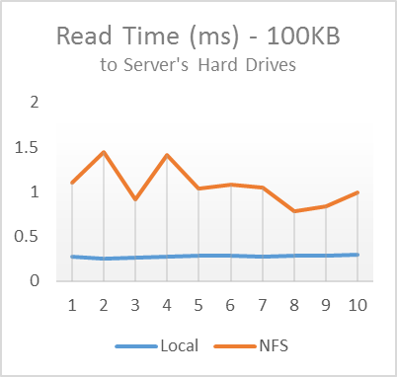
Fig 18. Read Time to Server’s Hard Drive – 100KB data size
The Table X shows the average of 1000 times read testing to server’s hard drives. The result shows that using local drive as virtual machine datastore is 285.12% faster than using NFS.
Table X
read Time to Server’s Hard Drive – 100KB data size
No. | Local Drive | NFS
1 | 0.2727091 | 1.1009283
2 | 0.2532925 | 1.4479928
3 | 0.2650531 | 0.9169837
4 | 0.2740736 | 1.4086522
5 | 0.2796387 | 1.0301360
6 | 0.2850377 | 1.0751110
7 | 0.2731174 | 1.0475101
8 | 0.2846108 | 0.7864894
9 | 0.2864403 | 0.8413505
10 | 0.2896118 | 0.9882189
Avg | 0.2763585 | 1.06433729
Figure 19 shows the values of write time (ms) from client to server’s hard drives on 1MB data size. The graph clearly shows that the using local drive is need less time than NFS on writing 1MB data size to server’s hard drives.
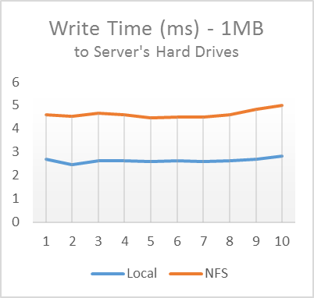
Fig 19. Write Time to Server’s Hard Drive – 1MB data size
Table XI
Write Time to Server’s Hard Drive – 1MB data size
No. | Local Drive | NFS
1 | 2.6951906 | 4.6125644
2 | 2.4538437 | 4.5276795
3 | 2.6429746 | 4.6541678
4 | 2.6237479 | 4.5839958
5 | 2.6098378 | 4.4526557
6 | 2.6108253 | 4.4808464
7 | 2.6094093 | 4.5075496
8 | 2.6389205 | 4.6009523
9 | 2.7065288 | 4.8241163
10 | 2.8184016 | 5.0088768
Avg | 2.64096801 | 4.62534046

The Table XI shows the result of measuring write speed from client to server’s hard drive on 1MB data size. The test conducted 1000 times and shows that the write time (ms) using local drive as virtual machine datastore is 75.13% faster than NFS on writing 1MB data size.
Figure 20 shows the values of read time (ms) from client to server’s hard drives on 1MB data size. The graph clearly shows that the using local drive is need less time than NFS on reading 1MB data size.
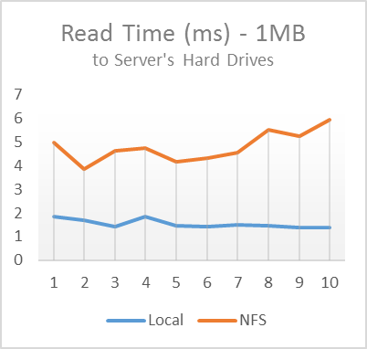
Fig 20. Read Time to Server’s Hard Drive – 1MB data size
The Table XII shows the result of measuring read speed from client to server’s hard drive on 1MB data size. The test conducted 1000 times and shows that the read time (ms) using local drive as virtual machine datastore is 212.13% faster than NFS on reading 1MB data size.
Table XII
Read Time to Server’s Hard Drive – 1MB data size
No. | Local Drive | NFS
1 | 1.8280787 | 4.9922166
2 | 1.7018325 | 3.8379347
3 | 1.4340294 | 4.6196290
4 | 1.8379318 | 4.7546660
5 | 1.4574793 | 4.1798378
6 | 1.4069189 | 4.3161234
7 | 1.4892594 | 4.5611101
8 | 1.4590108 | 5.5375688
9 | 1.3681861 | 5.2294828
10 | 1.3829000 | 5.9326323
Avg | 1.53656269 | 4.79612015
Figure 21 shows the values of write time (ms) from client to server’s hard drives on 10MB data size. The graph clearly shows that the using local drive is need less time than NFS on writing 10MB data size.
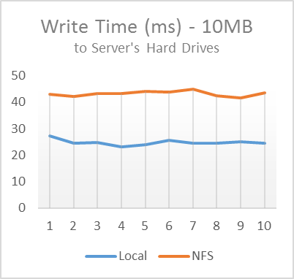
Fig 21. Write Time to Server’s Hard Drive – 10MB data size
The Table XIII shows the result of measuring write speed from client to server’s hard drive on 10MB data size. The test conducted 1000 times and shows that the write time (ms) using local drive as virtual machine datastore is 74.52% faster than NFS on writing 10MB data size.
Table XIII
Write Time to Server’s Hard Drive – 10MB data size
No. | Local Drive | NFS
1 | 27.1478046 | 43.0757329
2 | 24.4528828 | 42.1070175
3 | 24.6816513 | 43.2469012
4 | 23.1744430 | 43.2497131
5 | 24.0107874 | 44.0722654
6 | 25.6908536 | 43.9439595
7 | 24.5191706 | 44.9724713
8 | 24.6346203 | 42.5227648
9 | 24.9806222 | 41.6700380
10 | 24.4733174 | 43.5520640
Avg | 24.77661532 | 43.24129277
Figure 22 shows the values of read time (ms) from client to server’s hard drives on 10MB data size. Same as the previous test with smaller data size, the graph clearly shows that the using local drive is need less time than NFS on writing 10MB data size.
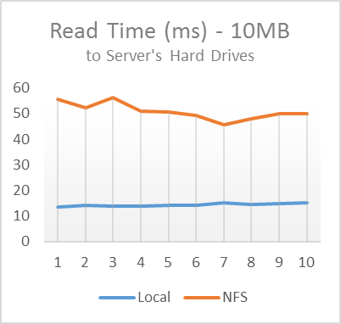
Fig 22. Read Time to Server’s Hard Drive – 10MB data size
Table XIV
Read Time to Server’s Hard Drive – 10MB data size
No. | Local Drive | NFS
1 | 13.6111554 | 55.4404134
2 | 14.2858530 | 52.3000522
3 | 13.7428692 | 56.3048110
4 | 13.7763704 | 50.8230918
5 | 14.0682058 | 50.6481013
6 | 14.1392855 | 49.2817658
7 | 15.0144403 | 45.5446373
8 | 14.6455623 | 48.1021028
9 | 14.6736816 | 49.9587382
10 | 15.2351220 | 49.9417438
Avg | 14.31925455 | 50.83454576
The Table XIV show the average of 1000 times read testing on 10MB data size to server’s hard drives. The test results show that the reading time using of local drive as virtual machine datastore is 255.00% faster than using NFS on 10MB data size.
Figure 23 shows the values of write time (ms) from client to server’s hard drives on 100MB data size.
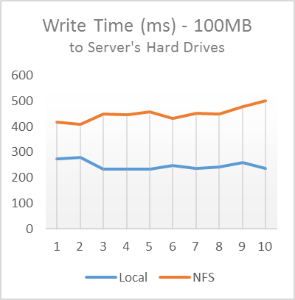
Fig 23. Write Time to Server’s Hard Drive – 100MB data size
The Table XV shows the average of 1000 times write testing on 100MB data size to server’s hard drive. The using of local drive as virtual machine datastore is 85.50% faster than NFS on writing test with 100MB data size.
Table XV
Write Time to Server’s Hard Drive – 100MB data size
No. | Local Drive | NFS
1 | 274.3238606 | 417.0823187
2 | 279.8248629 | 409.0026006
3 | 234.8885168 | 449.6597092
4 | 234.4858092 | 447.0694994
5 | 233.5891321 | 456.4545487
6 | 248.3101872 | 430.8372765
7 | 236.5735981 | 452.3911742
8 | 241.9112925 | 449.6875946
9 | 258.0254186 | 477.5778424
10 | 236.4137314 | 501.0387831
Avg | 242.0793223 | 449.0801347
Figure 24 shows the values of read time (ms) from client to server’s hard drives on 100MB data size.
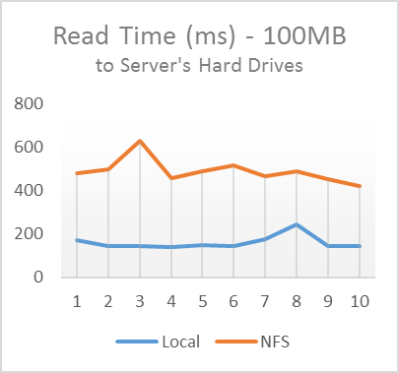
Fig 24. Read Time to Server’s Hard Drive – 100MB data size
The Table XVI shows the average of 1000 times read testing on 100MB data size to server’s hard drive. The using of local drive as virtual machine datastore is 241.75% faster than NFS on reading test with 100MB data size.
Table XVI
Read Time to Server’s Hard Drive – 100MB data size
No. | Local Drive | NFS
1 | 169.3189876 | 477.4720540
2 | 143.0246905 | 495.5157169
3 | 143.8852889 | 626.7372177
4 | 139.7862835 | 454.7121857
5 | 148.8176113 | 485.5323793
6 | 141.6053269 | 515.4512313
7 | 172.7155342 | 465.0021034
8 | 242.9524225 | 486.3185271
9 | 142.4901530 | 452.8320866
10 | 144.6938519 | 419.7914595
Avg | 142.7744716 | 487.9364962
- Round-trip Time from Client to Server
The third testing scenario is measuring RTT value from client to server. The testing was conducted by sending the various size of data packet to server and measure the delay from source to destination and vice versa. When we need to calculate a data and send to be processed on server, we need to know the transmit time needed between client-server, regardless of the time required in the calculations on the server. Figure 25 shows the RTT values between client-server in 4000 times write/read test. The test was conducted when we did testing on schenario 1 (write/read to server’s cache memory).
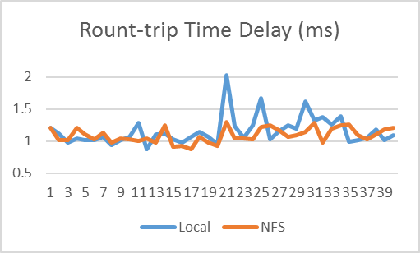
Fig 25. Round-trip Time
The Figure 25 shows the graph from 40 times testing with 100 data packet in a test. The average RTT in 4000 times testing by using local drive is 1.15ms and 1.09ms for using NFS as virtual machine datastore. Therefore, the using of NFS is 6.15% faster than local drive as virtual machine datastore.
- Conclusion and Future Work
This research proposed the using of NFS protocol on NAS storage as vSphere ESXi datastore. The using of NFS can improve manageability on upgrading server’s storage space. The test results on write process from client to server’s cache memory shows the using of NFS are more stable and faster than local drive as virtual machine datastore on 100KB and 1MB data size, until 10MB and 100MB data size testing that shows the using of local drive become more faster than NFS. The write process to server’s cache memory shows contradiction between NFS and local drive as virtual machine datastore on the used of data size. The test on smallest data size (100KB) shows NFS are faster than local drive. However, after the data size is enlarged, the results shows increased speed on the using of local drive and decrease the speed on the use of NFS as virtual machine datastore.
Same as the results of write test, the read test to server’s cache memory showed the same pattern. On the testing using a small data shows the use of NFS are faster than local drive. After the data size is enlarged, the results shows the using of local drive becomes better than NFS. Therefore, the use of NFS as virtual machine datastore is suitable for data communication on the cache memory that uses a small data size. The local drive is suitable for data communication on the cache memory that uses a bigger data size.
The test results on write/read speed from client to server’s hard drive shows the using of local drive at host hardware as virtual machine datastore are faster than using NFS. The write speed by using local drive as datastore aproximately 70% faster than using NFS. The read speed by using local drive aproximately 250% faster than using NFS.
The RTT test shows the using of local drive and NFS approx showed almost the same performance. The using of NFS as virtual machine datastore is just 6.15% faster than local drive after 4000 times testing with various data size.
There are still needed to measure the using of NFS as virtual machine datastore in more diverse data size to get more accurate results related to perfomance compared to using local drive at host hardware. Also considering the security aspects by using NFS as virtual machine datastore, for the ease of data tapping over the network when the write/read is in process. The security enhancement in the use of NFS as datastore can be done by configuring security protocol for authentication and encrypted data communication. However, there are still need further testing to measure the impact of security methods which will be used related to the data communication performance.

Reference
[1] | Avanade, “Server Virtualization: A Step Toward Cost Efficiency and Business Agility,” Avanade Inc, Seattle, Washington, 2009.
[2] | J. C. Flores Cruz dan T. Atkison, “Digital Forensics on a Virtual Machine,” dalam Proceedings of the 49th Annual Southeast Regional Conference, 2011.
[3] | B. D dan H. E, “Computer Forensics Analysis in a Virtual Environment,” International Journal of Digital Evidance, vol. 6, 2007.
[4] | M. A. Siddiqui dan H. Kamal, “A Proposed Approach for Deploying Network Attached Storage by Configuring Virtual Switch In ESXi,” dalam International Journal of Scientific and Engineering Research, 2014.
[5] | V. Stewart, M. Slisinger, L. Touchette dan P. Learnmonth, “NetApp and VMWare vSphere Storage Best Practices,” NetApp Technical Report, 2009.
[6] | I. Zhang, T. Denniston, Y. Baskakov dan A. Garthwaite, “Optimizing VM Checkpointing for Restore Performance in VMWare ESXi,” dalam USENIX Annual Technical Conference, 2012.
[7] | D. Sarddar dan R. Bose, “Architecture of Server Virtualization Technique Based on VMWare ESXI server in the Private Cloud for an Organization,” International Journal of Innovation and Scientific Research, vol. 12, pp. 284-294, 2014.
[8] | H. F. Kazan, L. Perneel dan M. Timmerman, “Benchmarking the Performance of Microsoft Hyper-V server, VMware ESXi and Xen Hypervisors,” Journal of Emerging Trends in Computing and Information Sciences, vol. 12, 2013.
[9] | J. Hiner, B. Detwiler dan T. Bowers, Executive's guide to Virtualization in the Enterprise, Louisville: TechRepublic, 2013.
[10] | C. D. Graziano, “A Performance Analysis of Xen and KVM Hypervisors for Hosting the Xen World Project,” Iowa State University, 2011.
[11] | P. Dwivedi, “Application of Virtualization Technology in Networked,” International Journal of Electronics and Communication, vol. 3, pp. 165-174, 2014.
[12] | K. Rai, A. Sharma dan M. Tanwar, “Operating System Virtualization,” International Journal of Innovative Research in Tehcnology, vol. 1, no. 5, 2014.
[13] | Oracle, System Administrator Guide: Oracle Solaris Containers-Resource Management and Oracle Solaris Zones, Oracle Corporation, 2010.
[14] | C. Gurr, “Fasilitating Microsoft Windows Vista Migration Through Application Virtualization,” Dell Power Solutions, 2008.
[15] | S. R. Signh, “Virtualization and Information Security - A Virtualized DMZ Design Consideration Using VMWare ESXi 4.1,” Unitec Institute of Technology, 2012.
[16] | VMWare, VMWare, 2017. [Online]. Available: www.vmware.com/solutions/consolidation/mission critical.Html.
[17] | C. Brenton, “Virtualization Security,” Cloud Security Alliance white papers.
[18] | R. U. e. al., “Intel Virtualization Technology,” IEEE Internet Computing, vol. 35, 2005.
[19] | VMWare , “Architecture of VMWare ESXi,” VMWare, 2008.
[20] | F5 Networks, “Trends in Enterprise Virtualization Technologies,” F5 Networks, 2008.
[21] | S. Lowe, Mastering VMWare VSphere 5, Wiley India/Goels Computer Hut, 2012.
[22] | M. Padovano, “System and method for accessing a storage area network as network attached storage”. US Paten US6606690 B2, 12 Aug 2003.
[23] | H. Gobioff, G. Gibson dan D. Tygar, “Security for Network Attached Storages Devices,” U.S. Department of Defense, 1997.
[24] | B. Nowicki, NFS: Network File System Protocol specification, Sun Microsystems, Inc, 1989.

